- Purpose

This procedure describes how to properly fill out the Acid Car History Log (P12-PR-200-F007).

- Scope

This procedure applies to the Acid Car History Log and should be followed anytime the log is being filled out.

- Responsibility

Material Handlers, or Lead Operators in their absence, will be responsible for this procedure.

- Safety Considerations

Before approaching the Railcar or Truck containing Sulfuric Acid put on the following Personal Protective Equipment: Safety Goggles, Face Shield, Acid Suit, Rubber Boots and Rubber Gloves.

If you’re unloading a railcar, the warning sign (blue) must be in place and the wheels of the railcar chocked during unloading. Giles lock must be on track derail before hooking up railcars.

Safety is a condition of employment. Employees are not authorized to work in an unsafe manner and are prohibited from harming the environment of the facility or the community.

- Materials/Equipment

- Black or Blue Pen

- Procedure

Follow Acid Unloading Procedure (P12-PR-200-005) for handling Acid cars – this Procedure is just for filling out the Acid Car History Log (P12-PR-200-F007).

  - When an Acid car is spotted by the rail road the Material Handler or designee is responsible for printing out a new Acid Car History Log for the car.

  - Each car gets its on log.

  - All appropriate information is to be filled in before unloading the car

    - The car number
    - Time spotted
    - Seal Number

  - The car can then be sampled, hooked up and dumped following the Acid Unloading Procedure.

  - If the operator is unable to finish dumping car during their shift, the next shift takes over on the log initialing beside each section they are responsible for.

    - Each section MUST be initialed by responsible person.

  - If there are issues with a car it is the responsibility of the Operator to fill out all information involved with the car. This will be the only record of problems or issues with this car. Inform the Plant Manager if the problems or issues prevent the car from being reloaded so it can be released to a maintenance facility for repairs.

  - Inform the Plant Manager if the railcar is due or past due for a lining inspection. The railcar will then have to be released back to the owner of the car, not returned to the vendor.

  - Once the car is finished unloading and all appropriate measure have been made, the Material Handler or Lead Operator is to sign the log stating:

“I have physically checked this railcar and placards. I declare it empty and ready to return”

* When signing this statement Operators are taking responsibility for this car.

  - Operators are to notify the Plant Manager that the car is ready. The completed log is to be placed with all other completed shift work logs to be picked up by the Plant Manager and turned in to the Quality department to be reviewed and filed.

SAMPLE ACID CAR HISTORY LOG FORM
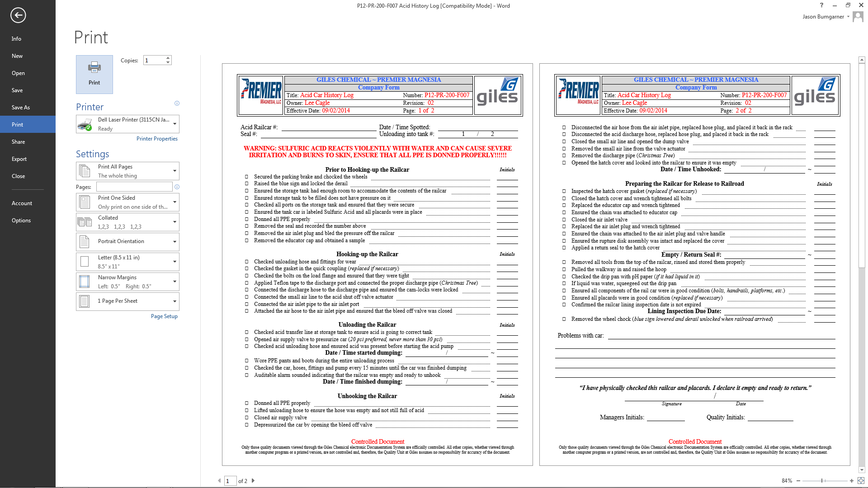
Operator must initial each line as they complete the task.
When car is finished dumping, unhooked and placards checked Operator is to sign official release of the car.

This signature is stating Operator takes responsibility or ownership for releasing this car.
Write down any problems or issues you have with the car. This is the only way we can track car problems, and know to release the car back to the owner not the vendor.
Operator must check the lining inspection due date and record here. If the lining is past due for inspection, please inform the plant manager so the car can be released back to the owner, not the vendor, for an inspection.
- Reference Documents

Acid Car History Log (P12-PR-200-F007)
Acid Unloading Procedure (P12-PR-200-005)

- Change Information

  - Changed the Sample Acid Car History Log Form to the revised form.
  - Added information about reporting problems or issues with the railcar to the Plant Manager.
  - Added a step to check the lining inspection due date and reporting if due or past due.
  - Changed the layout of the header to include new artwork.

